SECTION 1:

1. newly configured Domain Password Policy:

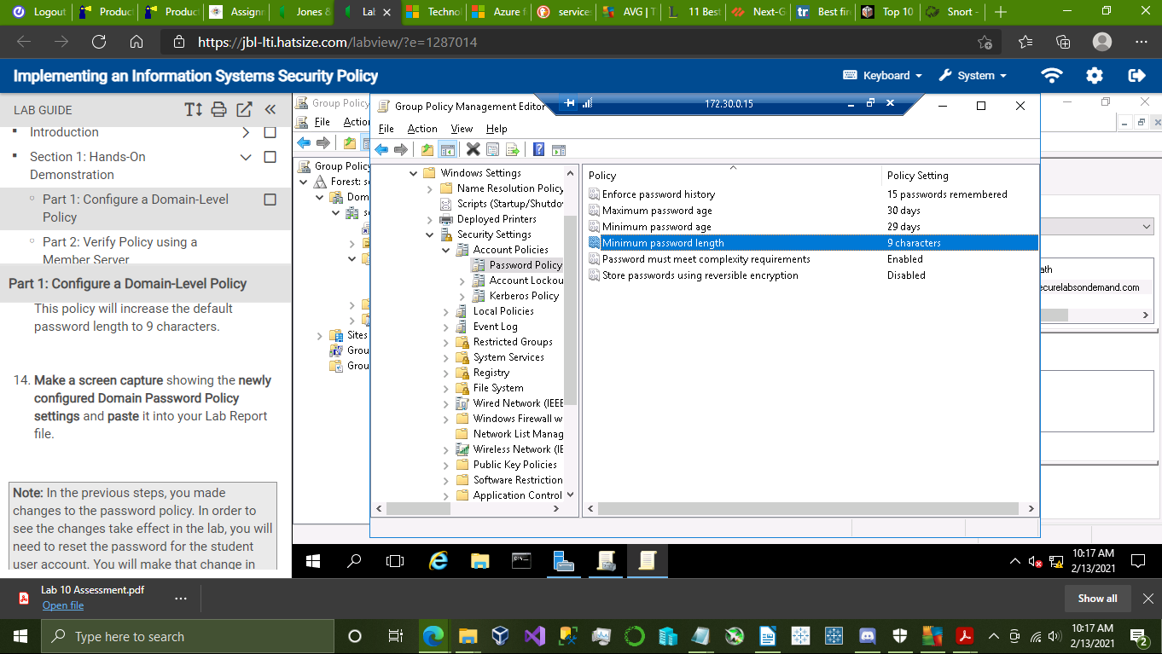

2. newly configured Account Lockout Policy:

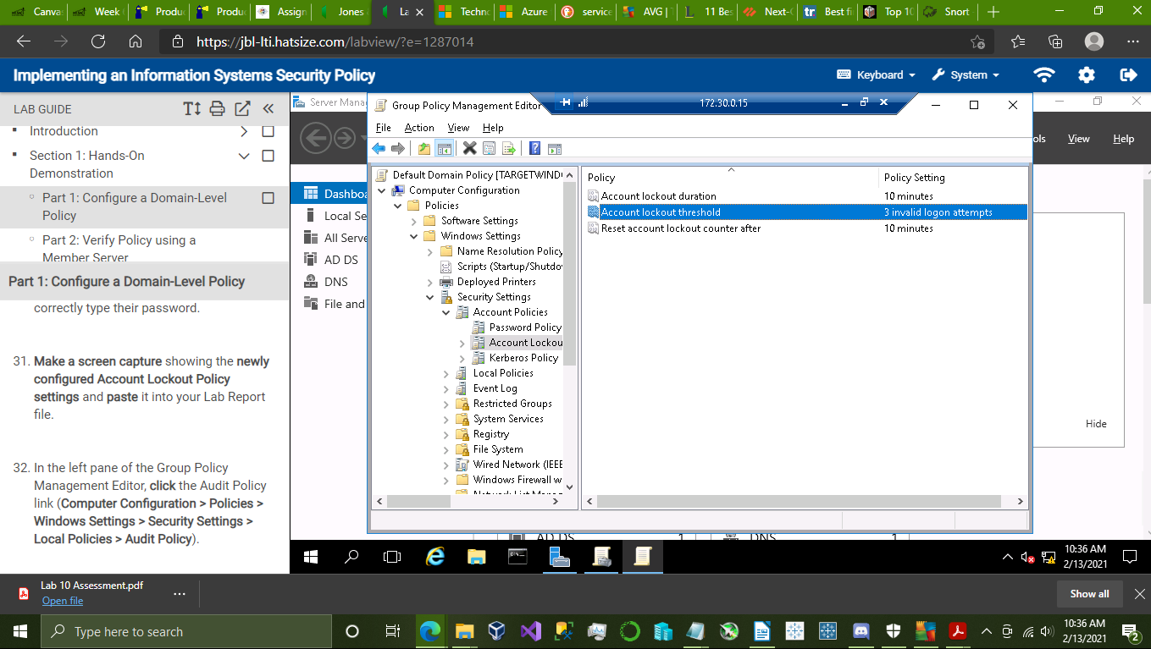

3. student user account logged on to TargetWindowsMen03:

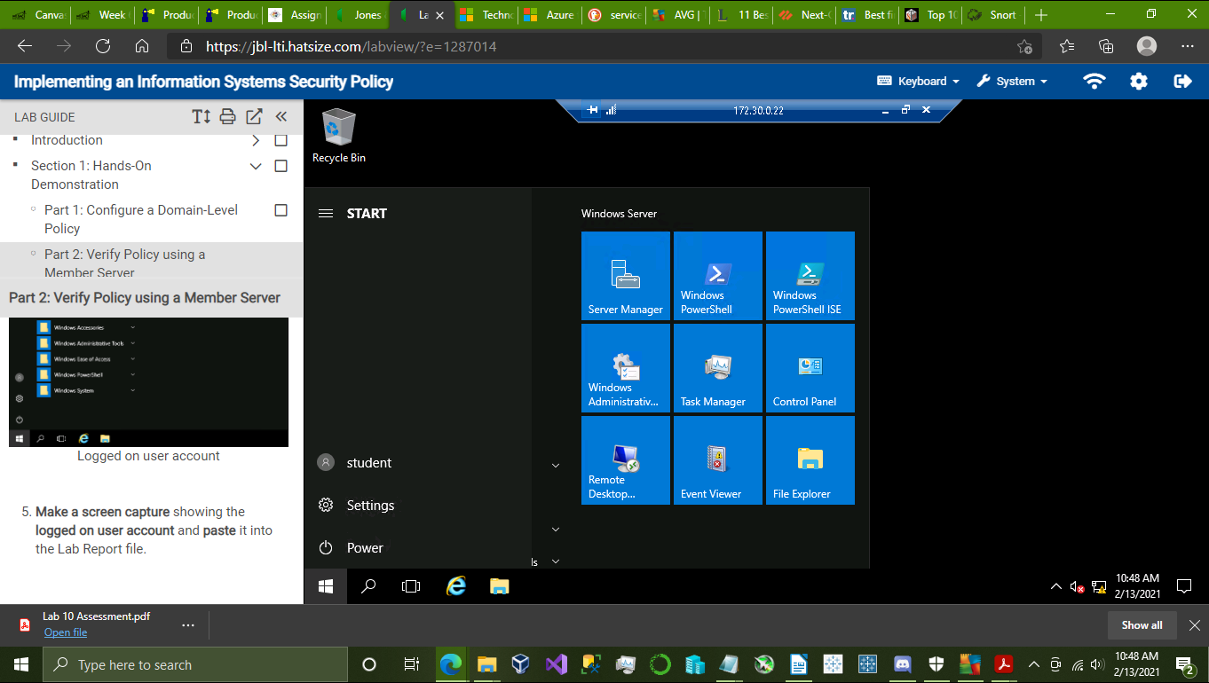

4. Administrator account logged on to TargetLinux01:

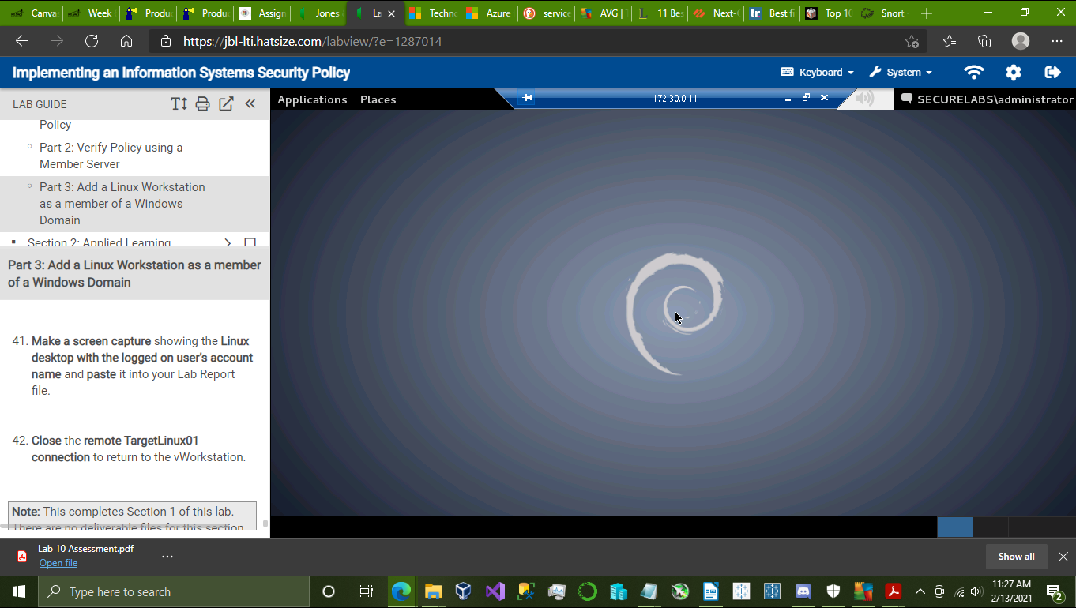

SECTION 2:

1. newly configured Domain password policies:

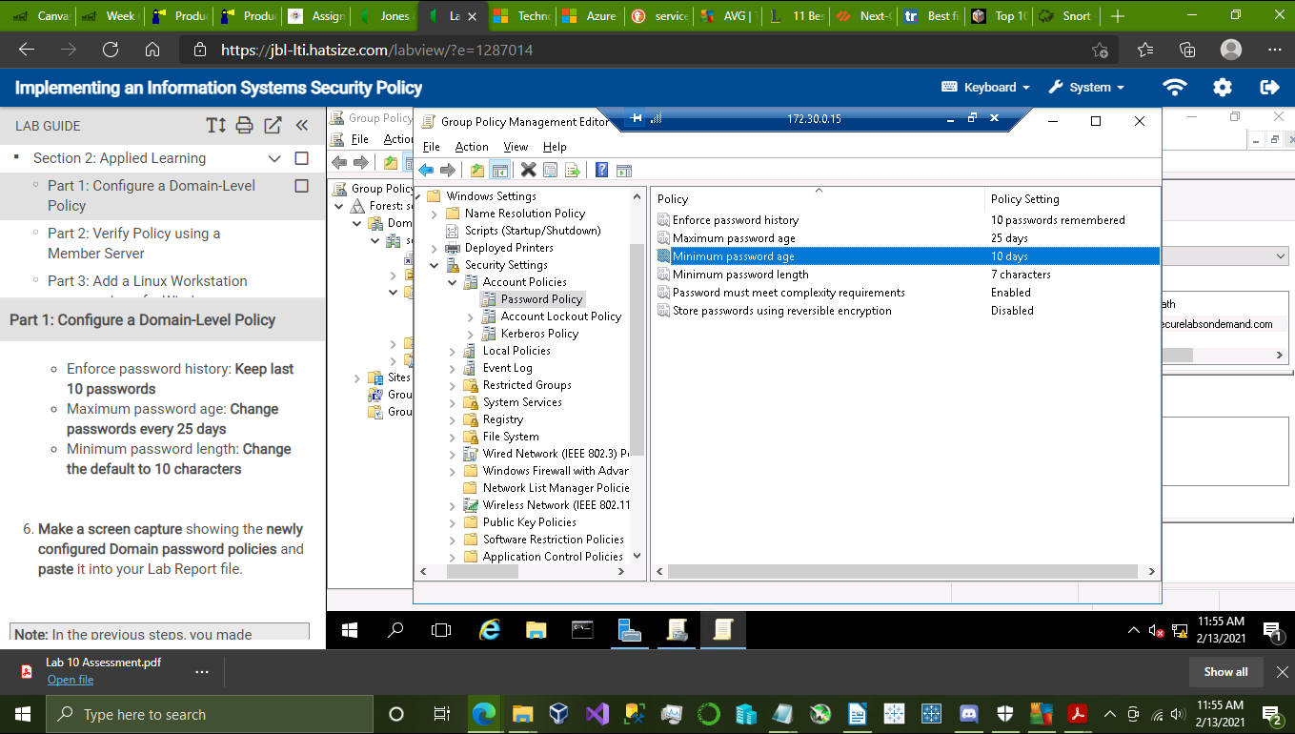

2. newly configured Account Lockout Policy

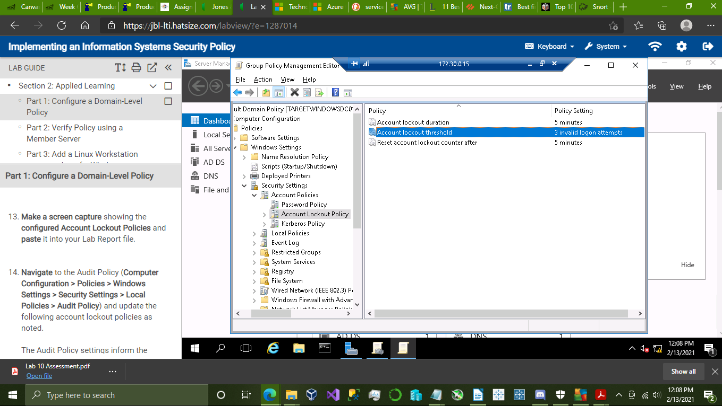

3. student user account logged on to TargetWindowsMem03

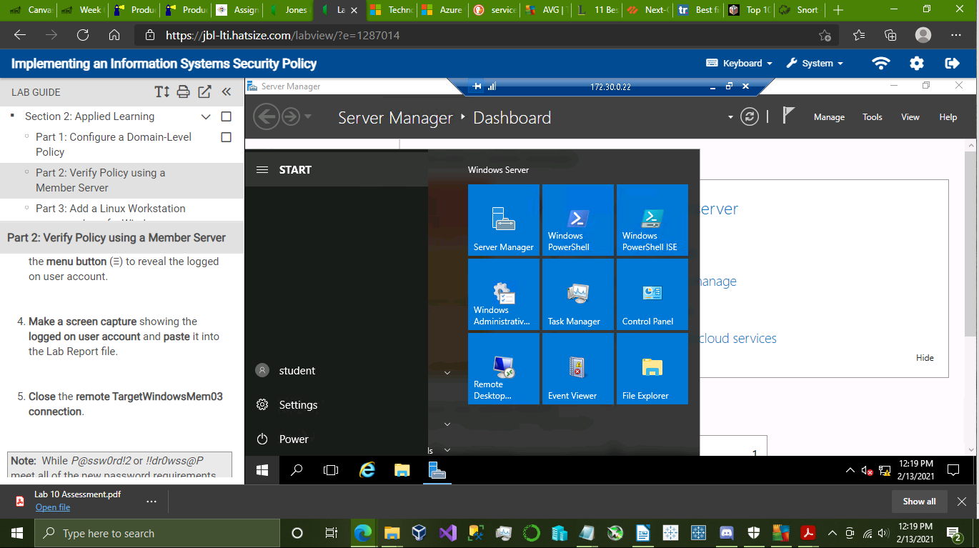

4. Administrator account logged on to TargetLinux01

